**Data Sources**

The data on Washington state counties was obtained from [*World Population Review*](https://worldpopulationreview.com/us-counties/washington), which provided a list of each county and their total population in 2024. To determine the percentage of the population identified as “white alone”, data for each county was gathered from the [*US Census Bureau*](https://www.census.gov/quickfacts/fact/table/WA/RHI425223). Finally, the [*Washington Secretary of State*](https://results.vote.wa.gov/results/20241105/export.html)website provided an export of the state’s 2024 election results. This export provided results for all elections across each county. The data was filtered to include only statewide elections for president, senator, and state governor. During data cleaning, the party column was standardized, as both “GOP” and “Republican” were present. “GOP” was replaced with “Republican” to match the assignment wording. Since the focus is on the two major US political parties, independent candidates and write-ins were removed.

There are no concerns about the data provided by the sources above. Two of them are from official government sources and the other was provided by the assignment.

**Specification**

To examine the fairness of "one person, one vote," we need to analyze population distribution and districting. In our model, we set the desired district population at 750,000 with six districts. We then calculate the ideal population by dividing the state's total population by the number of districts. The objective function calculates the absolute difference between the projected population of each district and this ideal population. Since we aim to minimize deviation from the ideal population regardless of whether it's an over- or underrepresentation, the objective function seeks to minimize the total absolute population deviation across all districts. The optimization problem then seeks to find the optimal assignment of counties to districts (represented by variables) that minimizes this deviation, potentially incorporating other relevant objectives.

**Programming**

https://github.com/hamodikk/algorithmic-rediscticting/tree/main

**Solution**

With the optimal solution, Washington state is suggested to be redistricted into 10 districts. In our original code, the program could not provide an optimal solution due to the unbalanced population allocation, especially in King County and Pierce County, which occupied 40% of the population in Washington state. Therefore, we separated the programming for those two counties and added a population tolerance of 15%. After solving the integer programming problem, we added back the two counties making up four districts. The specifics of the King and Pierce County segmentation are unable to be calculated by our model as it only uses county data, however our approach ensures each district will have roughly the same population.

**Maps and Discussion**

Current Washington congressional districts map is as below.

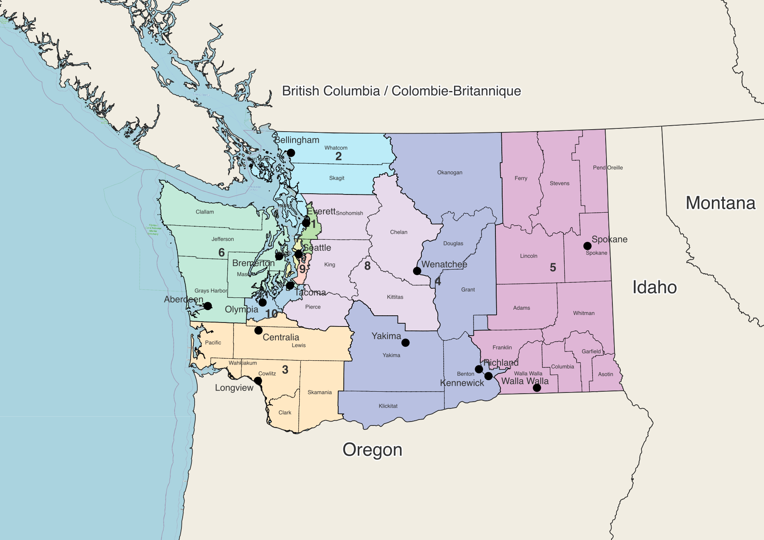

Our solution of redistrict.

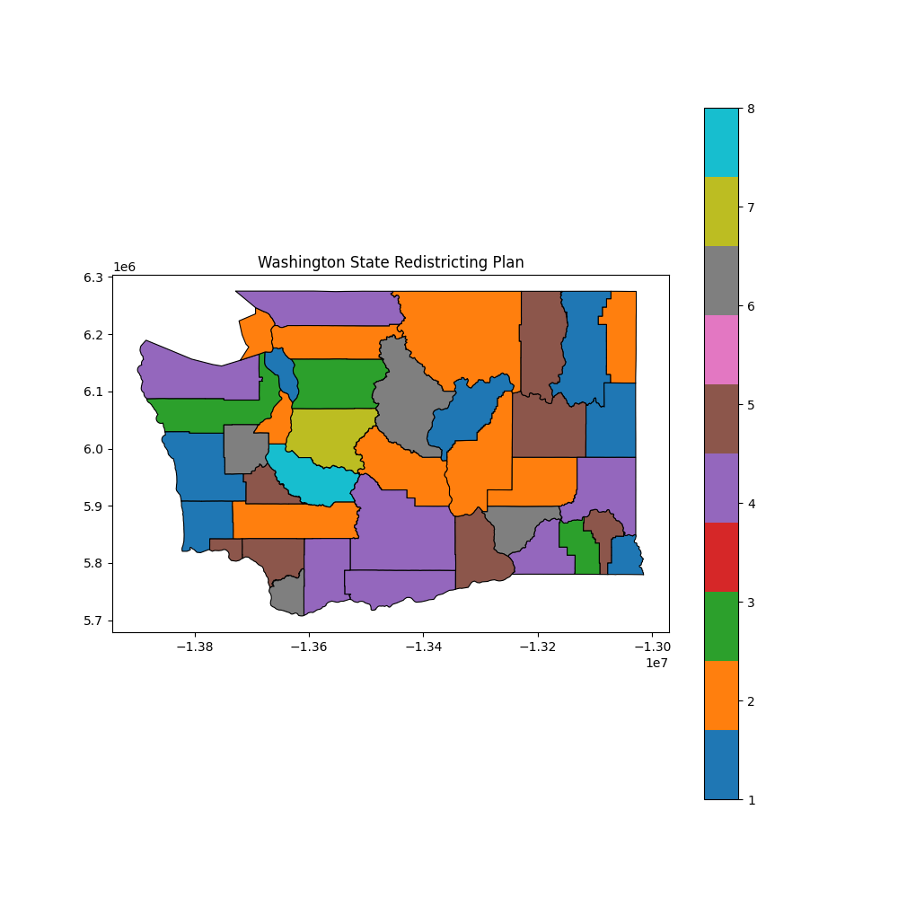

Redistricted districts may not be adjacent, unlike the current map. As the program considers the fairness of population distribution to ensure one person, one vote, the geographic distribution may be inconsistent and non-adjacent. A disadvantage of this solution might be confusion for people when voting and increased administrative or management expenses for the local government.